WHY? WHO? HOW?
This is the foundational lesson to start with when discipling new believers or existing Christians.

WHY has jesus saved you? Use 2 Corinthians 5:17-21 and/or Matt. 28:19-20

- From 2 Cor. 5:17-21: Becaused He loves you enough to make you a “new creation”.
- Because he wants you to share the “message of reconciliation” and the “ministry of reconciliation”. He considers you one of His “ambassadors”.

WHO do we share the gospel with? Your relational network. In other words, your friends, family, relatives, co-workers, neighbors and anyone else you know and have a relationship with.

- List 20 people who don’t have a relationship with God. Use a blank piece of paper. Pray through the list and ask God to show you 5 people that you can share your story and God’s story with this coming week.

HOW do we share the gospel? Share your story as a bridge to sharing God’s story.

- How to share your story in 1 - 3 minutes:
Share about your life before following Jesus.

Share about why you choose to follow Jesus.

Share about your life after following Jesus and the difference He has made.

? Make sure to ask for a response at the end of your story that leads into God’s story.

- There are many methods to share God's story. Here is one called the 3 Circles:
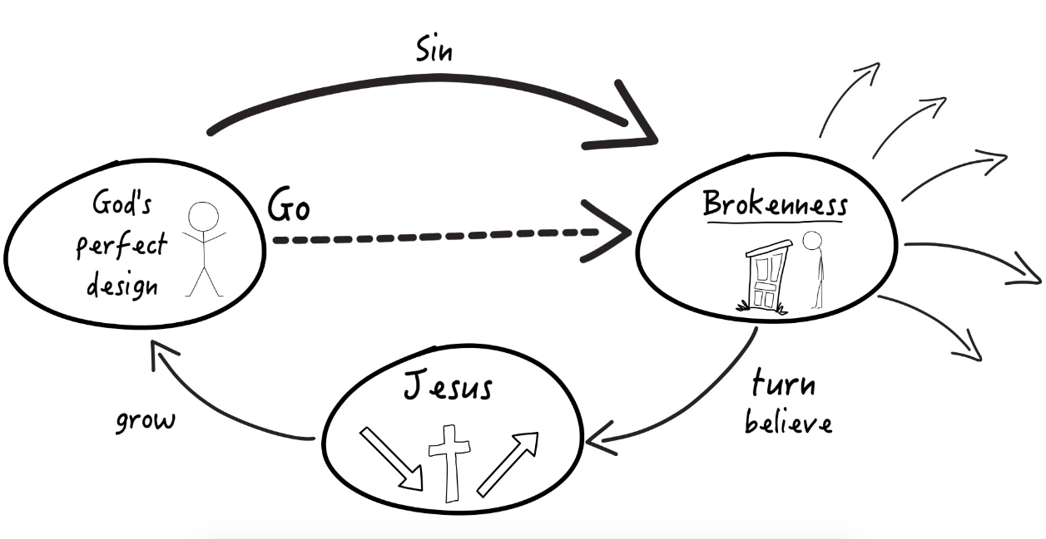

YOUR RELATIONAL NETWORK

Make a list of 20 non-Christians that you know. They could be your your friends, family, relatives, co-workers, neighbors or anyone else that you know and have a relationship with.

1. _________________________________________________
2. _________________________________________________
3. _________________________________________________
4. _________________________________________________
5. _________________________________________________
6. _________________________________________________
7. _________________________________________________
8. _________________________________________________
9. _________________________________________________
10. _________________________________________________
11. _________________________________________________
12. _________________________________________________
13. _________________________________________________
14. _________________________________________________
15. _________________________________________________
16. _________________________________________________
17. _________________________________________________
18. _________________________________________________
19. _________________________________________________
20. _________________________________________________

YOUR STORY - Sharing what God has done in your life

If you are seeking to share your story with someone you do not know in order to introduce them to God’s story, it is helpful to think in terms of three stories: their story, your story and God’s story.

Their Story: It is helpful if you can get them to share about their spiritual journey in order that you might be able to adapt your presentation about your story and God’s story to be appropriate for their worldview, values and priorities.

Your Story: Think of your story in three parts also. Learn to share your story in 1-3 minutes:
Share about your life before following Jesus.

Share about why you choose to follow Jesus.

Share about your life after following Jesus and the difference He has made.

? Ask for a response at the end of your story that leads into conversation.

NOTE: If you want another way to share your story, you can always share about how God has made a difference in your life, helped you, healed you, or brought you through a difficult circumstance, etc.

God’s Story: The main idea behind sharing your story is to open a door for you to share God’s story. Once the door is open, share God’s story with the person.

Write your story in the space below. Look for ways to share it with the people on your list of 100.

________________________________________________________

________________________________________________________________________________________________________________

________________________________________________________________________________________________________________

________________________________________________________? ________________________________________________________________________________________________________________

GOD’S STORY - Sharing The Gospel
There are many possible ways to share God’s story. There is no “best” way. The best way for any given person will be different based on Scripture and include the person’s worldview,
experiences and the cultural/religious context that they live in
Here’s what to say when drawing out the 3 circles
So we live in this world, and it is characterized by brokenness. We don’t have to look very hard to see that there are things like disease, disasters, war, broken families...there’s a lot of pain in this world. But this is not God’s original design. God has a perfect design for our lives. The way that we have gotten ourselves into brokenness is through something the Bible calls sin. Sin is turning away from God’s design and pursuing our own way, and that leads us to brokenness. Brokenness eventually leads us to death, and that death will separate us from God forever. But God doesn’t want us to stay in brokenness.

So He’s made a way out, and that way is Jesus. Jesus comes, and he enters into our brokenness, and the death that we deserve for pursuing brokenness, Jesus takes on himself and dies on a cross, and his body is broken for us. Three days after he died, he rose from the dead and made a way out of brokenness. People try many things to get out of brokenness. Things like religion, success, money, relationships, education, or drugs and alcohol, but none of these things can get us out of brokenness. The only way out is Jesus. If we turn from our sin and believe that Jesus died for us and rose from the dead, we can leave brokenness and grow in a relationship with God and pursue his perfect design for our lives. And more than that, we can go. We can be sent just like Jesus, back into brokenness, to help others come through him to pursue God’s design.

Now there are two types of people in the world, there are people that are pursuing God’s design, and there are people that are still in brokenness. We have to ask ourselves, “Where are we?” So, where do you think you are?.

